Spatial machine learning
Prof. Katarzyna Kopczewska
University of Warsaw, Faculty of Economic Sciences
kkopczewska@wne.uw.edu.pl
updated 12.03.2026

Neural network + spatial neural network

Spis treści
# 0. Vocabulary 2
# 1. Extra preparation of data 3
# 2. Artificial Neural Network model with neuralnet:: package 3
# let’s try to make the model more spatial – spatial lags of variables included 15
# Extra codes 18
# ***Comparison of different specifications of NN models 18
# *** calculating spatial lag for subsample of points 20

After this class students should be able to:
- Understand what a neural network does in a spatial ML context
- Explain how spatial information can be introduced into ML models
- Train a basic neural network in R
- Evaluate classification performance (accuracy, precision, recall, ROC/AUC)
- Construct spatial lags and include them as predictors
This frames the class better than starting immediately with definitions.

=====================================

Spatial machine learning is about including information from the neighbourhoods and/or about the (absolute / relative) location

What kind of spatial variables we can include in the model:
1. To represent location:
a) x,y coordinates
b) distance to cities – dist.lublin, min.dist
c) dummy if location in high-density cluster - COREfirms
2. To represent neighbourhoood:
a) average values in the neighbourhood – spatial lag of variable
b) number of observations around – structure of neighbourhood

calculating spatial lag for subsample of points
- spatial lag is the average of values in the neighbourhood
- instead of typical spatial weights matrix algorithm one can operationalize it
- with indicating who is a neighbour and calculating a mean on subsample

# 0. Vocabulary

Dense layer - a hidden layer that is fully connected to the preceding layer

Output –
- for binary classification, Neural Network (NN) can simply use a sigmoid function to directly compute a probability
- for multiclass problem, NN usually requires a softmax transformation, whereby all values across all k output units sum up to one and can thus be treated as probabilities
- rather than having categorical predictions you can retrieve the actual probabilities, which are much more informative, and inspect their quality using calibration plots and lift charts

Weights - each weight is essentially one of many coefficient estimates that contribute to the regressions computed in the nodes (see arrows in the figures). For any particular observation each neuron can be mathematically represented as , where b denotes the intercept (also known as bias, and technically a weight itself) and W and x are m-long vectors carrying the weights and values from all m inputs, respectively. Before training, all weights are initialized with random values.

Regularization – form of weight decay is like L2 or LASSO penalties; it introduces a budget for the magnitude of the weights. It helps to avoid overfitting and constrains model flexibility.

Computation - the unknown parameters must be tuned by the model to minimize the loss function, using an optimization procedure. Loss function is a measure of goodness-of-fit, that compares predictions and known labels over all training observations – e.g. cross-entropy .

Activation functions
- On / off sigmoid
- high-pass toggle switches rectified linear unit (ReLU)

Optimiser - an optimization method that computes the gradient descent, essentially tweaking all weight estimates simultaneously, in the directions that improve the goodness-of-fit, e.g. Adam (stochastic method)

Backpropagation – backward analysis to update weights

Batch size - how many observations to be used in each training step, trade-off between accuracy and runtime
- Stochastic batch - feed in single observations
- mini-batch - feed in samples
- full-batch – feed in entire training set

Epoch – number of iterations. There is no optimal method to set it, but it is important to consider the number of epochs that can aid in extending iterations beyond the size of the training set.

Options in commands
- err.fct error function sse (sum of squared errors) lub ce (cross-entropy)
- act.fct activating function - used for smoothing the result of the cross product of the covariate or neurons and the weights – logistic or tanh (tangent hyperbolicus)
- linear.output TRUE when act.function cannot be applied, otherwise FALSE
- likelihood calculates AIC and BIC
threshold stopping criteria for partial derivatives of the error function

# 1. Extra preparation of data

library(caret) # build stratified division (to keep proportions of given variable)
train_index<-createDataPartition(firms$SEC_agg, p=0.05, list=FALSE)
train_data<-firms[train_index, ] # 5% of all data - to make it quick
remain<-firms[-train_index, ]
test_index<-createDataPartition(remain$SEC_agg, p=0.05, list=FALSE)
test_data<-remain[test_index, ] # 4% of all data (5% from 95%)
xvars<-c("roa", "empl_av_size", "locPdens", "locAggTOTAL", "COREfirms", "locBIG", "dist.lublin", "min.dist")
yvars<-c("dummy_agri", "dummy_prod", "dummy_constr", "dummy_serv")

train_nn<-train_data[, c("SEC_agg", yvars, xvars)] # keep needed variables
test_nn<-test_data[, c("SEC_agg", yvars, xvars)]

train_nn<-na.omit(train_nn) # omit NA
test_nn<-na.omit(test_nn)

train_means<-sapply(train_nn[, xvars], mean) # save train scaling parameters
train_sds<-sapply(train_nn[, xvars], sd)

train_nn_scaled<-train_nn # scale train
train_nn_scaled[, xvars]<-scale(train_nn[, xvars], center=train_means, scale=train_sds)

test_nn_scaled<-test_nn # scale test using TRAIN parameters
test_nn_scaled[, xvars]<-scale(test_nn[, xvars], center=train_means, scale=train_sds)

Neural networks require scaling because weights depend on variable magnitude large ranges destabilize training and gradient descent converges faster

# 2. Artificial Neural Network model with neuralnet:: package

This model is to predict if given firm (we know the location and surrounding) operates in given sector (one of four) (see the dependent variable side dummy_agri + dummy_prod + dummy_constr + dummy_serv or simply SEC_agg

How to set architecture (option ‘hidden’)? Finding proper architecture is a mix of experience and trials – for example one can run a grid search (list and organize options to test and run models with all those options) – but it takes long. There is also a heuristic rule that number of neurons H should be around $H≈\frac{N}{10∙(p+k)}$, where N is a number of observations, p is a number of inputs and k is a number of outputs. For 8 inputs and 4 outputs and ca.1850 observation, it makes H=1850/(10*12)=15. Below we try two models – one smaller with 6 neurons hidden=(4,2) which has four neurons in the first layer and two neurons in the second layer., and one bigger with 15 neurons hidden=(5,5,5).

Please note that results will be “anything” – training good model takes hours, here we have something simple to see how it works.

install.packages("neuralnet")
library(neuralnet)
set.seed(123)
eq <- dummy_agri + dummy_prod + dummy_constr + dummy_serv ~ roa + empl_av_size + locPdens + locAggTOTAL + COREfirms + locBIG + dist.lublin + min.dist
model.nn1<-neuralnet(eq, data=train_nn_scaled[, c(yvars, xvars)], hidden=c(4, 2),
linear.output=FALSE, stepmax=1e7, lifesign="full")
model.nn2<-neuralnet(eq, data=train_nn_scaled[, c(yvars, xvars)], hidden=c(5, 5, 5),
linear.output=FALSE, stepmax=1e7, lifesign="full")

for model.nn1
hidden: 4, 2 thresh: 0.01 rep: 1/1 steps: 1000 min thresh: 0.392140452286242
2000 min thresh: 0.14876100857139
3000 min thresh: 0.0316752948902181
4000 min thresh: 0.0117232024523814
5000 min thresh: 0.0117232024523814
6000 min thresh: 0.0117232024523814
7000 min thresh: 0.0117232024523814
8000 min thresh: 0.0117232024523814
9000 min thresh: 0.0103222886917495
10000 min thresh: 0.0103106829431379
10029 error: 1.64202 time: 32.92 secs

for model.nn2
hidden: 5, 5, 5 thresh: 0.01 rep: 1/1 steps: 832 error: 1.00236 time: 3.43 secs
plot(model.nn1, rep="best")
plot(model.nn2, rep="best")

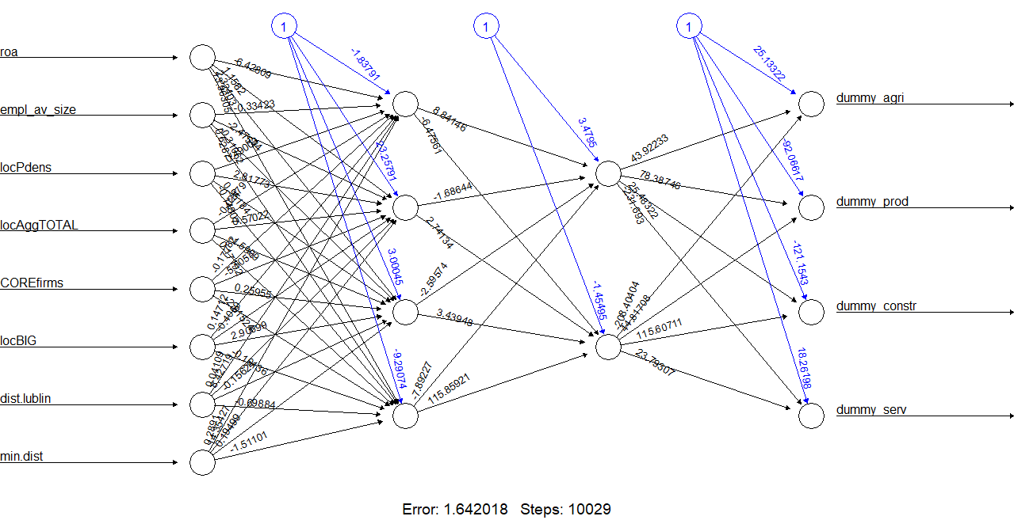

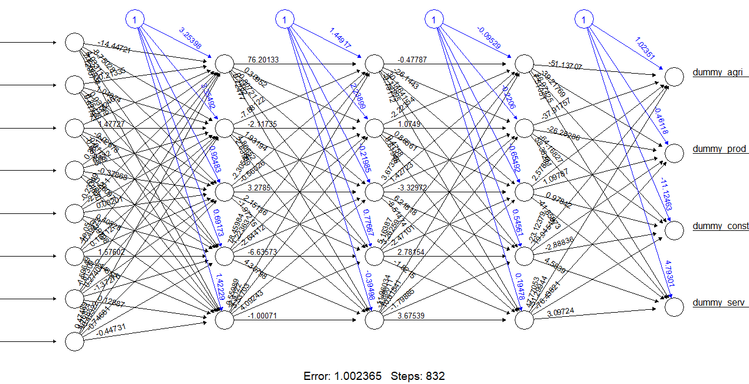

Plot of neural network, middle columns of “bubbles” are hidden layers. This plot (from neuralnet::) shows weights (somehow like coefficients).

library(NeuralNetTools) # alternative visualisation
plotnet(model.nn1)
#model.nn3<-neuralnet(eq, data=train_data, hidden=15) # with NeuralNetTools::

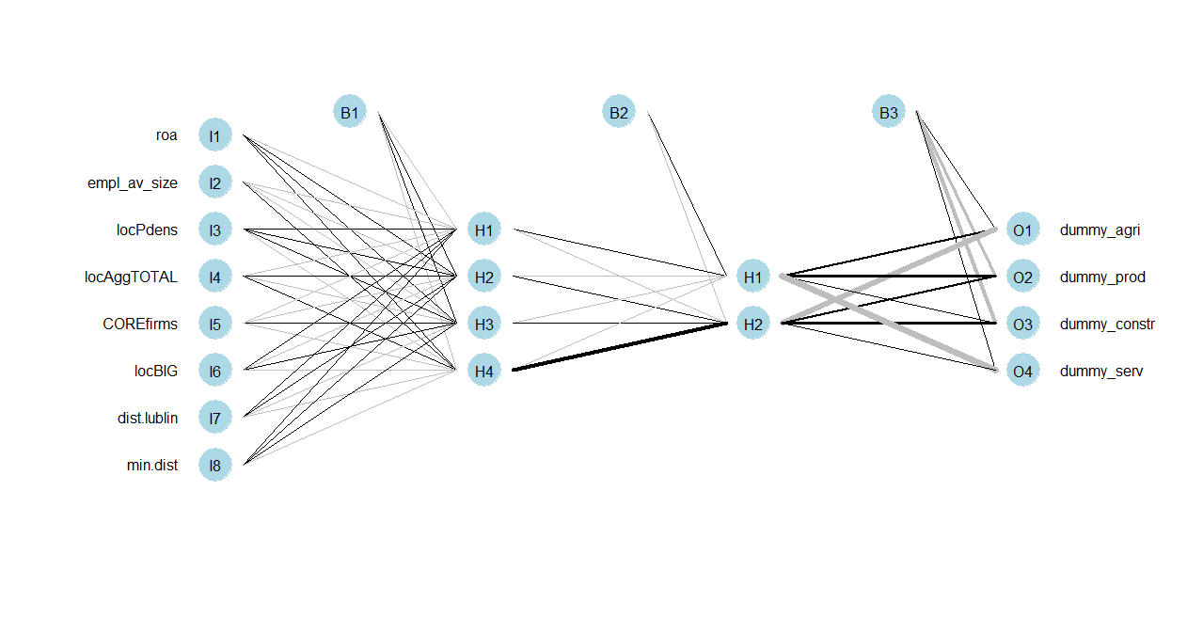

str(model.nn1)
List of 14
$ call : language neuralnet(formula = eq, data = train_nn_scaled[, c(yvars, xvars)], hidden = c(4, 2), stepmax = 1e+07, lifesign = | __truncated__
$ response : int [1:1871, 1:4] 1 0 0 1 0 1 1 1 0 1 ...
..- attr(*, "dimnames")=List of 2
.. ..$ : chr [1:1871] "59" "63" "71" "86" ...
.. ..$ : chr [1:4] "dummy_agri" "dummy_prod" "dummy_constr" "dummy_serv"
$ covariate : num [1:1871, 1:8] -0.841 1.143 1.654 -0.831 1.646 ...
..- attr(*, "dimnames")=List of 2
.. ..$ : chr [1:1871] "59" "63" "71" "86" ...
.. ..$ : chr [1:8] "roa" "empl_av_size" "locPdens" "locAggTOTAL" ...
$ model.list :List of 2
..$ response : chr [1:4] "dummy_agri" "dummy_prod" "dummy_constr" "dummy_serv"
..$ variables: chr [1:8] "roa" "empl_av_size" "locPdens" "locAggTOTAL" ...
$ err.fct :function (x, y)
..- attr(*, "type")= chr "sse"
$ act.fct :function (x)
..- attr(*, "type")= chr "logistic"
$ linear.output : logi FALSE
$ data :'data.frame': 1871 obs. of 12 variables:
..$ dummy_agri : int [1:1871] 1 0 0 1 0 1 1 1 0 1 ...
..$ dummy_prod : int [1:1871] 0 0 0 0 0 0 0 0 0 0 ...
..$ dummy_constr: int [1:1871] 0 0 0 0 0 0 0 0 1 0 ...
..$ dummy_serv : int [1:1871] 0 1 1 0 1 0 0 0 0 0 ...
..$ roa : num [1:1871] -0.841 1.143 1.654 -0.831 1.646 ...
..$ empl_av_size: num [1:1871] -0.0893 -0.0894 -0.0893 -0.0895 -0.0894 ...
..$ locPdens : num [1:1871] -0.631 -0.622 1.344 -0.64 2.407 ...
..$ locAggTOTAL : num [1:1871] -0.608 -0.569 0.776 -0.608 2.507 ...
..$ COREfirms : num [1:1871] -0.648 -0.648 1.543 -0.648 1.543 ...
..$ locBIG : num [1:1871] -0.429 -0.429 -0.429 -0.429 3.4 ...
..$ dist.lublin : num [1:1871] 0.343 -0.386 -1.476 0.556 -1.317 ...
..$ min.dist : num [1:1871] 0.512 0.844 -1.32 1.311 -1.006 ...
$ exclude : NULL
$ net.result :List of 1
..$ : num [1:1871, 1:4] 1.00 2.57e-80 2.65e-80 1.00 2.62e-80 ...
.. ..- attr(*, "dimnames")=List of 2
.. .. ..$ : chr [1:1871] "59" "63" "71" "86" ...
.. .. ..$ : NULL
$ weights :List of 1
..$ :List of 3
.. ..$ : num [1:9, 1:4] -1.8379 -6.4281 -0.3342 0.49 -0.0248 ...
.. ..$ : num [1:5, 1:2] 3.48 8.84 -1.69 -2.6 -7.89 ...
.. ..$ : num [1:3, 1:4] 25.1 43.9 -208.4 -92.1 78.4 ...
$ generalized.weights:List of 1
..$ : num [1:1871, 1:32] NaN -0.000858 -0.000603 NaN -0.009369 ...
.. ..- attr(*, "dimnames")=List of 2
.. .. ..$ : chr [1:1871] "59" "63" "71" "86" ...
.. .. ..$ : NULL
$ startweights :List of 1
..$ :List of 3
.. ..$ : num [1:9, 1:4] 0.0847 0.7541 -0.4993 0.2144 -0.3247 ...
.. ..$ : num [1:5, 1:2] 0.7076 -0.3637 0.0597 -0.7046 -0.7172 ...
.. ..$ : num [1:3, 1:4] -0.739 -0.574 -1.317 -0.183 0.419 ...
$ result.matrix : num [1:61, 1] 1.64 9.81e-03 1.00e+04 -1.84 -6.43 ...
..- attr(*, "dimnames")=List of 2
.. ..$ : chr [1:61] "error" "reached.threshold" "steps" "Intercept.to.1layhid1" ...
.. ..$ : NULL
- attr(*, "class")= chr "nn"

model.nn2$result.matrix
error 1.002365e+00
reached.threshold 9.327351e-03
steps 8.320000e+02
Intercept.to.1layhid1 3.253985e+00
roa.to.1layhid1 -1.444721e+01
empl_av_size.to.1layhid1 -2.133481e-01
locPdens.to.1layhid1 -3.224632e-01
locAggTOTAL.to.1layhid1 3.611189e-01

Interpretation:
- lower error is better on training data
- lower reached.threshold means gradients became small
- very large steps can indicate a difficult optimization problem

Compare observed vs fitted output means - this gives a rough sense whether the predicted output frequencies match the target frequencies.

# Generate predicted class scores and their labels - class distribution diagnostic
test_pred_raw<-compute(model.nn2, test_nn_scaled[, xvars])$net.result
colnames(test_pred_raw)<-yvars
head(test_pred_raw)
dummy_agri dummy_prod dummy_constr dummy_serv
6 1.867120e-01 8.022031e-01 1.244038e-15 7.907844e-15
36 1.000000e+00 6.885893e-09 1.280813e-26 1.112821e-14
43 2.746792e-38 7.797604e-14 1.237765e-05 1.000000e+00
61 1.000000e+00 1.244248e-11 1.281772e-29 1.028993e-14
80 2.454623e-38 7.229778e-14 1.035142e-05 1.000000e+00
102 4.633656e-32 1.190263e-09 9.999895e-01 5.745687e-10

colMeans(train_nn_scaled[, yvars])
dummy_agri dummy_prod dummy_constr dummy_serv
0.57250 0.03375 0.06500 0.32875
colMeans(test_pred_raw)
[1] 0.57250001 0.03469247 0.06584450 0.32875032

pred_class<-colnames(test_pred_raw)[max.col(test_pred_raw)]
pred_class<-sub("dummy_", "", pred_class)
true_class<-test_nn_scaled$SEC_agg
conf_mat<-table(Predicted=pred_class, Actual=true_class)
conf_mat
Actual
Predicted agri constr prod serv
agri 988 0 3 0
constr 0 94 2 0
prod 3 2 66 0
serv 0 1 0 617

Interpretation: Most observations lie on the diagonal, meaning they were classified correctly. Only a small number of misclassifications occur, for example: 3 agricultural firms were predicted as production and 2 production firms were predicted as construction. Overall the model classifies sectors very accurately.

table(true_class)
true_class
agri constr prod serv
991 97 71 617

table(pred_class)
pred_class
agri constr prod serv
991 96 71 618

prop.table(table(true_class))
true_class
agri constr prod serv
0.55799550 0.05461712 0.03997748 0.34740991

prop.table(table(pred_class))
pred_class
agri constr prod serv
0.55799550 0.05405405 0.03997748 0.34797297

Interpretation: The predicted proportions are almost identical to the real distribution. This suggests that the neural network correctly captures the overall structure of the data and does not strongly bias predictions toward one class.

# Accuracy, precision, recall, F1

Metric | What it measures | Key question
Accuracy | Overall correctness | How often is the model right?
Precision | Reliability of predictions | When the model predicts a class, is it correct?
Recall | Ability to find real cases | Does the model detect all real cases?
F-score | Balance of precision and recall | How good is the trade-off between precision and recall?
Support is the number of real observations belonging to a given class in the dataset.
accuracy<-sum(diag(conf_mat)) / sum(conf_mat) # overall accuracy
accuracy
[1] 0.993

Interpretation: The model correctly classifies 99.3% of all firms in the test dataset. This indicates very high predictive performance of the neural network.

classes<-colnames(conf_mat) # Per-class metrics
classes
[1] "agri" "constr" "prod" "serv"
metrics<-data.frame(class=classes, precision=NA, recall=NA, f1=NA, support=NA)
for (i in seq_along(classes)) {
cl <- classes[i]
tp <- conf_mat[cl, cl]
fp <- sum(conf_mat[cl, ]) - tp
fn <- sum(conf_mat[, cl]) - tp
precision <- ifelse(tp + fp == 0, NA, tp / (tp + fp))
recall <- ifelse(tp + fn == 0, NA, tp / (tp + fn))
f1 <- ifelse(is.na(precision) | is.na(recall) | (precision+recall==0), NA,
2 * precision * recall / (precision + recall))
metrics$precision[i] <- precision
metrics$recall[i] <- recall
metrics$f1[i] <- f1
metrics$support[i] <- sum(conf_mat[, cl])}
metrics

class precision recall f1 support
1 agri 0.9969728 0.9969728 0.9969728 991
2 constr 0.9791667 0.9690722 0.9740933 97
3 prod 0.9295775 0.9295775 0.9295775 71
4 serv 0.9983819 1.0000000 0.9991903 617

Interpretation:
- Agriculture (agri) – very high precision and recall (≈0.997), meaning the model almost always correctly identifies agricultural firms.
- Construction (constr) – slightly lower performance but still very high (F1 ≈ 0.97).
- Production (prod) – the lowest performance among classes (F1 ≈ 0.93), which may result from the small number of observations in this category.
- Services (serv) – almost perfect classification (recall = 1), meaning all real service firms were correctly detected.

# Balanced accuracy (agri is much more common than prod)
balanced_accuracy<-mean(metrics$recall, na.rm = TRUE)
balanced_accuracy
[1] 0.97368298

Interpretation: Balanced accuracy averages recall across all classes and is useful when class sizes are unequal (e.g., agriculture is much more common than production). A value of 0.974 shows that the model performs very well across all sectors, not only in the dominant class.

# ROC and AUC for each class – due to multiclass outputs, do one-vs-rest ROC curves

Because the model predicts multiple classes (sectors), ROC analysis is performed using a one-vs-rest approach. This means that for each class (e.g., agriculture), the model compares: that class (1) vs. all other classes combined (0). So we evaluate how well the model can separate each sector from the rest of the firms.

The ROC curve (Receiver Operating Characteristic) shows the relationship between: True Positive Rate (Recall / Sensitivity) and False Positive Rate for different classification thresholds. A curve closer to the top-left corner indicates better classification performance. A curve close to the diagonal line means the model performs no better than random guessing.

The AUC (Area Under the Curve) summarizes the ROC curve in a single number between 0 and 1.
AUC value | Interpretation
0.5 | Random prediction
0.6–0.7 | Weak model
0.7–0.8 | Acceptable
0.8–0.9 | Good
0.9–1.0 | Excellent

For each sector (dummy_agri, dummy_prod, dummy_constr, dummy_serv), the code
- Computes an ROC curve comparing that sector vs all others.
- Calculates the AUC value, which measures how well the neural network distinguishes firms in that sector.
If AUC values are close to 1, it means: the model very effectively separates firms belonging to that sector from others, predicted probabilities are well calibrated, and classification quality is very high.

library(pROC)
auc_results<-list()
for (j in seq_along(yvars)) {
y_name <- yvars[j]
roc_obj <- roc(response = test_nn_scaled[[y_name]], predictor = test_pred_raw[, j])
auc_results[[y_name]] <- auc(roc_obj)
print(paste(y_name, auc(roc_obj)))
plot(roc_obj, main = paste("ROC:", y_name))
}

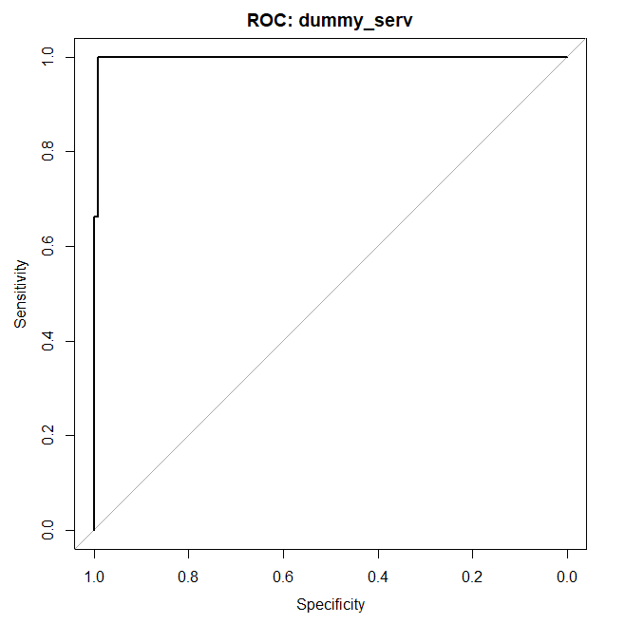

# Cross-entropy - a classification-oriented loss on the test set - lower is better

Cross-entropy (also called log loss) measures how well the predicted probabilities match the true class labels. It evaluates the quality of probability predictions, not only whether the final class prediction is correct. The formula penalizes predictions that assign low probability to the true class.
Cross-entropy values are always ≥ 0. Lower values indicate better predictions. A value close to 0 means the model assigns high probability to the correct class.
The obtained value (0.0218) is very low, which indicates that the neural network predicts probabilities very close to the true classes, incorrect predictions are rare and usually occur with low confidence, the model is well calibrated.

eps<-1e-15
pred_clip<-pmin(pmax(test_pred_raw, eps), 1 - eps)
y_true<-as.matrix(test_nn_scaled[, yvars])
logloss<- -mean(y_true*log(pred_clip) + (1-y_true) * log(1-pred_clip))
logloss
[1] 0.02180817
Overfitting discussion: right now one may think that 99% accuracy = perfect model, which is risky, as it may result from overfitting. Possible reasons for high accuracy are class imbalance, spatial clustering, leakage from spatial lags or overly simple classification task. Therefore spatial ML model should address potential pitfalls as overfitting, spatial autocorrelation or data leakage when computing spatial lags.

# ALTERNATIVE DIAGNOSTICS

The caret:: package is the easiest for confusion matrix and class metrics. It is very convenient for confusion matrix, accuracy, sensitivity / specificity, class-wise diagnostics. It gives overall and balanced accuracy, Kappa, class-wise sensitivity, specificity, positive and negative predictive value.

library(caret)
pred_factor<-factor(pred_class, levels = c("agri", "prod", "constr", "serv"))
true_factor<-factor(true_class, levels = c("agri", "prod", "constr", "serv"))
confusionMatrix(pred_factor, true_factor) # from caret::

Confusion Matrix and Statistics
Reference
Prediction agri prod constr serv
agri 988 3 0 0
prod 3 66 2 0
constr 0 2 94 0
serv 0 0 1 617

Overall Statistics
Accuracy : 0.9938
95% CI : (0.9889, 0.9969)
No Information Rate : 0.558
P-Value [Acc > NIR] : < 2.2e-16

Kappa : 0.989
Mcnemar's Test P-Value : NA

Statistics by Class:

Class: agri Class: prod Class: constr Class: serv
Sensitivity 0.9970 0.92958 0.96907 1.0000
Specificity 0.9962 0.99707 0.99881 0.9991
Pos Pred Value 0.9970 0.92958 0.97917 0.9984
Neg Pred Value 0.9962 0.99707 0.99821 1.0000
Prevalence 0.5580 0.03998 0.05462 0.3474
Detection Rate 0.5563 0.03716 0.05293 0.3474
Detection Prevalence 0.5580 0.03998 0.05405 0.3480
Balanced Accuracy 0.9966 0.96332 0.98394 0.9996

95% Confidence Interval 95% CI = (0.9889, 0.9969) - the true classification accuracy is expected to lie between 98.9% and 99.7% with 95% confidence. This confirms the high reliability of the model’s accuracy.

No Information Rate (NIR) NIR = 0.558 - this is the accuracy obtained by always predicting the most frequent class (agriculture). Since 55.8% of firms belong to agriculture, a naive classifier would achieve 55.8% accuracy.

P-value (Accuracy > NIR) p-value < 2.2e-16 - the model performs significantly better than a naive classifier that predicts only the majority class. The improvement is statistically highly significant.

Cohen’s Kappa = 0.989 - Kappa measures agreement between predictions and actual classes after correcting for random chance. Values close to 1 indicate almost perfect agreement. Kappa between 0.6-0.8 is substantial and between 0.8-1 is almost perfect. Thus, 0.989 indicates nearly perfect classification quality.

McNemar’s Test McNemar p-value = NA - McNemar’s test evaluates asymmetry in classification errors. Here it cannot be computed because the number of certain error types is too small. This usually occurs when the classifier performs extremely well.

Statistics by class - These metrics evaluate performance separately for each sector.

Sensitivity (Recall) measures how many real cases are correctly detected - the model detects almost all firms in each sector. Service firms are detected perfectly (recall = 1).

Specificity measures how well the model avoids falsely assigning a class - The classifier almost never assigns the wrong sector.

Positive Predictive Value (Precision) - Precision measures how reliable predictions of a class are - when the model predicts a sector, it is almost always correct.

Negative Predictive Value - This measures how reliable predictions not belonging to a class are. All values are above 0.996, meaning that when the model predicts that a firm does not belong to a given sector, this is almost always correct.

Prevalence Prevalence shows the true share of each sector in the dataset - agriculture dominates the dataset. Production and construction are relatively small classes.

Detection rate - This shows the proportion of observations that are correctly classified into a given class. For example: agriculture: 55.6% of all observations are correctly classified agricultural firms.

Detection prevalence - This shows the proportion of observations predicted as a class. The values are very close to the true prevalence, meaning the model reproduces the real class distribution well.

Balanced accuracy accuracy averages sensitivity and specificity - all sectors have very high balanced accuracy. Even smaller classes (production and construction) are classified very reliably.

yardstick — modern tidy diagnostics - This is very good if you want clean metric functions

install.packages("yardstick")
install.packages("dplyr")

library(yardstick)
library(dplyr)
results_df <- data.frame(
truth = factor(true_class, levels = c("agri", "prod", "constr", "serv")),
estimate = factor(pred_class, levels = c("agri", "prod", "constr", "serv"))
)
accuracy(results_df, truth = truth, estimate = estimate)
bal_accuracy(results_df, truth = truth, estimate = estimate)
precision(results_df, truth = truth, estimate = estimate, estimator = "macro")
recall(results_df, truth = truth, estimate = estimate, estimator = "macro")
f_meas(results_df, truth = truth, estimate = estimate, estimator = "macro")
conf_mat(results_df, truth = truth, estimate = estimate)

> accuracy(results_df, truth = truth, estimate = estimate)
# A tibble: 1 × 3
.metric .estimator .estimate
<chr> <chr> <dbl>
1 accuracy multiclass 0.985
> bal_accuracy(results_df, truth = truth, estimate = estimate)
# A tibble: 1 × 3
.metric .estimator .estimate
<chr> <chr> <dbl>
1 bal_accuracy macro 0.966
> precision(results_df, truth = truth, estimate = estimate, estimator = "macro")
# A tibble: 1 × 3
.metric .estimator .estimate
<chr> <chr> <dbl>
1 precision macro 0.925
> recall(results_df, truth = truth, estimate = estimate, estimator = "macro")
# A tibble: 1 × 3
.metric .estimator .estimate
<chr> <chr> <dbl>
1 recall macro 0.937
> f_meas(results_df, truth = truth, estimate = estimate, estimator = "macro")
# A tibble: 1 × 3
.metric .estimator .estimate
<chr> <chr> <dbl>
1 f_meas macro 0.929
> conf_mat(results_df, truth = truth, estimate = estimate)
Truth
Prediction agri prod constr serv
agri 109 0 0 0
prod 1 5 1 0
constr 0 0 12 0
serv 0 1 0 71

pROC:: — easiest ROC/AUC package
install.packages("pROC")
library(pROC)
roc_agri <- roc(test_nn_scaled$dummy_agri, test_pred_raw[, "dummy_agri"])

roc_agri<-roc(test_nn_scaled$dummy_agri, test_pred_raw[, "dummy_agri"])
roc_prod<-roc(test_nn_scaled$dummy_prod, test_pred_raw[, "dummy_prod"])
roc_constr<-roc(test_nn_scaled$dummy_constr, test_pred_raw[, "dummy_constr"])
roc_serv<-roc(test_nn_scaled$dummy_serv, test_pred_raw[, "dummy_serv"])

auc(roc_agri)
#Area under the curve: 0.9919
auc(roc_prod)
#Area under the curve: 0.8703
auc(roc_constr)
#Area under the curve: 1
auc(roc_serv)
#Area under the curve: 0.9974
plot(roc_agri, col="green")
plot(roc_prod, add=TRUE, col="brown")
plot(roc_constr, add=TRUE, col="yellow")
plot(roc_serv, add=TRUE, col="blue")

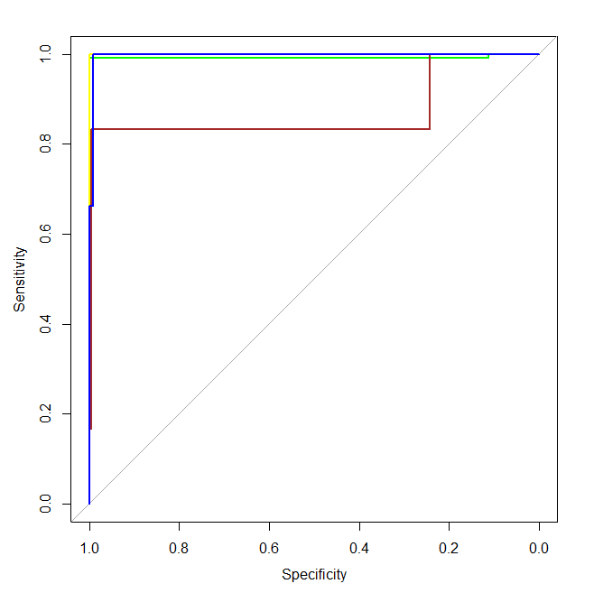

NeuralNetTools:: — best package specifically for interpreting neural nets. It works with neural network models and provides functions for variable importance, plotting weights, network structure inspection, Garson / Olden algorithms

install.packages("NeuralNetTools")
library(NeuralNetTools)
olden(model.nn2)
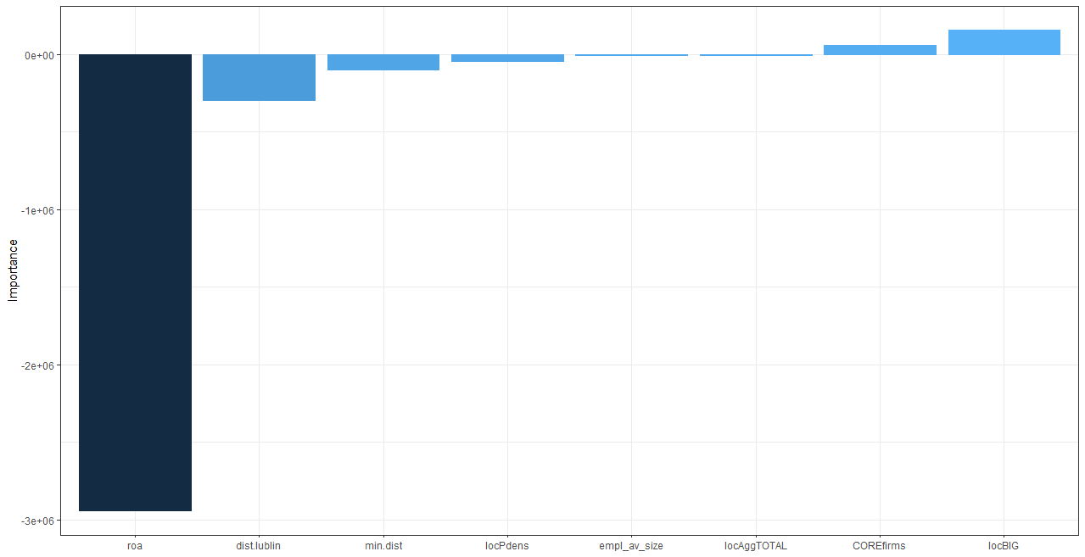

garson(model.nn2)
Błąd w poleceniu 'garson.default(wts_in, x_names, y_names, ...)':
Garson only applies to neural networks with one output node

library(caret)
model3<-train(eq, method='nnet', data=train_data, linout=TRUE)
garson(model3) # variable importance

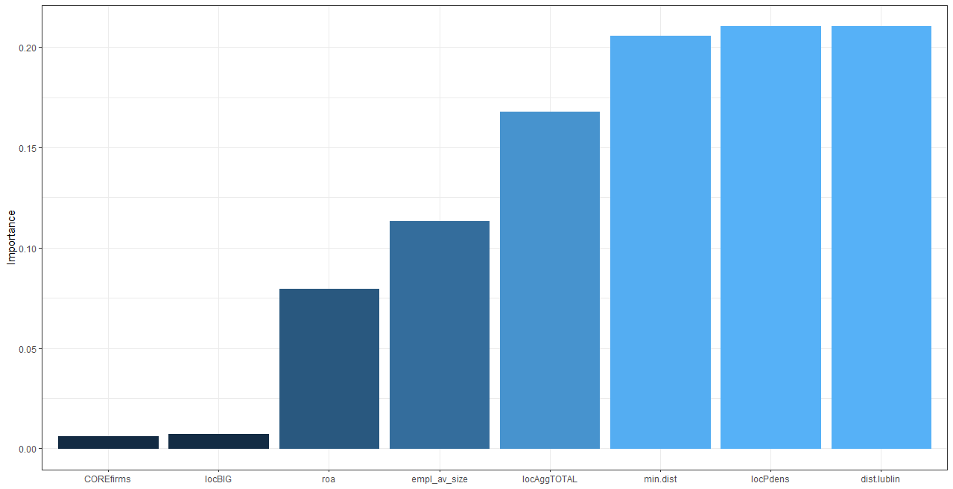

model3 # displaying the results of model
Neural Network

800 samples
11 predictor

No pre-processing
Resampling: Bootstrapped (25 reps)
Summary of sample sizes: 800, 800, 800, 800, 800, 800, ...
Resampling results across tuning parameters:

size decay RMSE Rsquared MAE
1 0e+00 0.0029362532 NaN 2.844887e-04
1 1e-04 0.0000173157 NaN 4.914668e-06
1 1e-01 0.0013428192 NaN 4.111193e-04
3 0e+00 0.0034498229 NaN 2.700282e-04
3 1e-04 0.0001053134 NaN 3.371260e-05
3 1e-01 0.0019038842 NaN 6.929527e-04
5 0e+00 0.0096953773 NaN 6.507511e-04
5 1e-04 0.0003026711 NaN 1.488616e-04
5 1e-01 0.0018317704 NaN 6.996160e-04

RMSE was used to select the optimal model using the smallest value.
The final values used for the model were size = 1 and decay = 1e-04.

What else one can use?
NeuralSens:: — for sensitivity analysis, to understand how predictors affect outputs.
DALEX:: - model-agnostic explainability package, if you can wrap prediction into a function, DALEX can give you: variable importance, partial dependence, breakdowns, model explanations
iml:: - very good explainability package, similar in spirit to DALEX. It is useful for: feature importance, partial dependence, ICE curves, Shapley values. It also needs a prediction wrapper, but then it works nicely.

# let’s try to make the model more spatial – spatial lags of variables included

Add spatial lags – average in the neighbourhoods. As below, compute spatial lags within train and test sets separately, which is correct. Do not compute them on the full dataset using both train and test data because information from the test set leaks into training.

install.packages("devtools") # to install from Github
devtools::install_github("poktam/spatialWarsaw")
library(spatialWarsaw)

# spatial lags for train data
train_data.sf<-st_as_sf(train_data, coords=c("new.x", "new.y"), crs=4326)
my.tess<-tessW(train_data.sf, region.voi, sample_size=nrow(test_data.sf))
my.tess # spatial weights matrix based on Voronoi tesselation
Characteristics of weights list object:
Neighbour list object:
Number of regions: 1871
Number of nonzero links: 10956
Percentage nonzero weights: 0.3129713
Average number of links: 5.855692

Weights style: W
Weights constants summary:
n nn S0 S1 S2
W 1871 3500641 1871 663.1726 7638.817

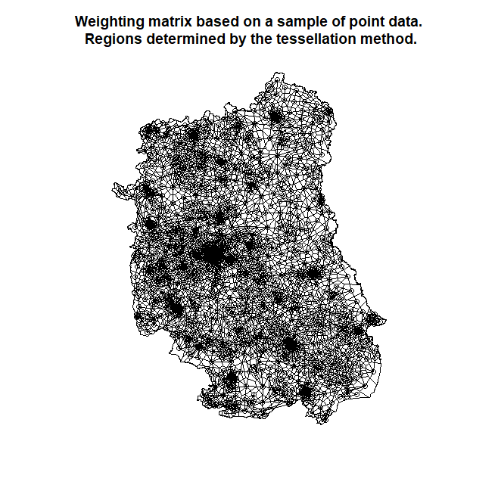

train_data$dummy_agri.slag<-lag.listw(my.tess, train_data$dummy_agri)
train_data$dummy_prod.slag<-lag.listw(my.tess, train_data$dummy_prod)
train_data$dummy_constr.slag<-lag.listw(my.tess, train_data$dummy_constr)
train_data$dummy_serv.slag<-lag.listw(my.tess, train_data$dummy_serv)

train_data$roa.slag<-lag.listw(my.tess, train_data$roa)
train_data$empl_av_size.slag<-lag.listw(my.tess, train_data$empl_av_size)
train_data$locPdens.slag<-lag.listw(my.tess, train_data$locPdens)
train_data$locAggTOTAL.slag<-lag.listw(my.tess, train_data$locAggTOTAL)
train_data$COREfirms.slag<-lag.listw(my.tess, train_data$COREfirms)
train_data$locBIG.slag<-lag.listw(my.tess, train_data$locBIG)
train_data$dist.lublin.slag<-lag.listw(my.tess, train_data$dist.lublin)
train_data$min.dist.slag<-lag.listw(my.tess, train_data$min.dist)

# spatial lags for test data
test_data.sf<-st_as_sf(test_data, coords=c("new.x", "new.y"), crs=4326)
my.tess<-tessW(test_data.sf, region.voi, sample_size=nrow(test_data.sf))

test_data$dummy_agri.slag<-lag.listw(my.tess, test_data$dummy_agri)
test_data$dummy_prod.slag<-lag.listw(my.tess, test_data$dummy_prod)
test_data$dummy_constr.slag<-lag.listw(my.tess, test_data$dummy_constr)
test_data$dummy_serv.slag<-lag.listw(my.tess, test_data$dummy_serv)

test_data$roa.slag<-lag.listw(my.tess, test_data$roa)
test_data$empl_av_size.slag<-lag.listw(my.tess, test_data$empl_av_size)
test_data$locPdens.slag<-lag.listw(my.tess, test_data$locPdens)
test_data$locAggTOTAL.slag<-lag.listw(my.tess, test_data$locAggTOTAL)
test_data$COREfirms.slag<-lag.listw(my.tess, test_data$COREfirms)
test_data$locBIG.slag<-lag.listw(my.tess, test_data$locBIG)
test_data$dist.lublin.slag<-lag.listw(my.tess, test_data$dist.lublin)
test_data$min.dist.slag<-lag.listw(my.tess, test_data$min.dist)

# model with less variables
eq <- SEC_agg ~ roa + empl_av_size + locPdens + locAggTOTAL + COREfirms + locBIG + dist.lublin + min.dist

# model with more variables
eq.slag <- SEC_agg ~ roa + empl_av_size + locPdens + locAggTOTAL + COREfirms + locBIG + dist.lublin + min.dist + dummy_agri.slag + dummy_prod.slag + dummy_constr.slag + dummy_serv.slag + roa.slag + empl_av_size.slag + locPdens.slag + locAggTOTAL.slag + COREfirms.slag + locBIG.slag + dist.lublin.slag + min.dist.slag
library(caret)
library(nnet)

# outcome must be a factor
train_data$SEC_agg<-factor(train_data$SEC_agg, levels=c("agri", "prod", "constr", "serv"))
test_data$SEC_agg <-factor(test_data$SEC_agg, levels=c("agri", "prod", "constr", "serv"))

train_data<-droplevels(train_data) # drop unused levels from a ‘factor’
test_data<-droplevels(test_data)
table(train_data$SEC_agg)
table(test_data$SEC_agg)
ctrl<-trainControl(method="cv", number=5, classProbs=TRUE)

# smaller model
model_smaller<-train(eq, data=train_data, method="nnet", trControl=ctrl, trace=FALSE)
pred_class<-predict(model_smaller, newdata=test_data) # predicted labels
pred_prob<-predict(model_smaller, newdata=test_data, type="prob") # pred.prob
confusionMatrix(pred_class, test_data$SEC_agg) # quality metrics
iii<-garson(model_smaller) # variable importance
iii@data # values sorted increasingly

# bigger model
model_bigger<-train(eq.slag, data=train_data, method="nnet", trControl=ctrl, trace=FALSE)
pred_class<-predict(model_bigger, newdata=test_data) # predicted labels
pred_prob<-predict(model_bigger, newdata=test_data, type="prob") # pred.prob
confusionMatrix(pred_class, test_data$SEC_agg) # quality metrics
iii<-garson(model_bigger) # variable importance
iii@data # values sorted increasingly

Smaller model | Bigger model
Confusion Matrix and Statistics  Reference  Prediction agri prod constr serv  agri 991 59 0 10  prod 0 0 0 0  constr 0 6 62 0  serv 0 6 35 607  Overall Statistics  Accuracy : 0.9347  95% CI : (0.9222, 0.9457)  No Information Rate : 0.558  P-Value [Acc > NIR] : < 2.2e-16  Kappa : 0.8786  Mcnemar's Test P-Value : NA  Statistics by Class:  Class: agri Class: prod Class: constr Class: serv  Sensitivity 1.0000 0.00000 0.63918 0.9838  Specificity 0.9121 1.00000 0.99643 0.9646  Pos Pred Value 0.9349 NaN 0.91176 0.9367  Neg Pred Value 1.0000 0.96002 0.97951 0.9911  Prevalence 0.5580 0.03998 0.05462 0.3474  Detection Rate 0.5580 0.00000 0.03491 0.3418  Detection Prevalence 0.5968 0.00000 0.03829 0.3649  Balanced Accuracy 0.9561 0.50000 0.81780 0.9742 | Confusion Matrix and Statistics  Reference  Prediction agri prod constr serv  agri 991 61 24 0  prod 0 4 19 1  constr 0 3 19 0  serv 0 3 35 616  Overall Statistics  Accuracy : 0.9178  95% CI : (0.904, 0.9302)  No Information Rate : 0.558  P-Value [Acc > NIR] : < 2.2e-16  Kappa : 0.8457  Mcnemar's Test P-Value : NA  Statistics by Class:  Class: agri Class: prod Class: constr Class: serv  Sensitivity 1.0000 0.056338 0.19588 0.9984  Specificity 0.8917 0.988270 0.99821 0.9672  Pos Pred Value 0.9210 0.166667 0.86364 0.9419  Neg Pred Value 1.0000 0.961758 0.95553 0.9991  Prevalence 0.5580 0.039977 0.05462 0.3474  Detection Rate 0.5580 0.002252 0.01070 0.3468  Detection Prevalence 0.6059 0.013514 0.01239 0.3682  Balanced Accuracy 0.9459 0.522304 0.59704 0.9828
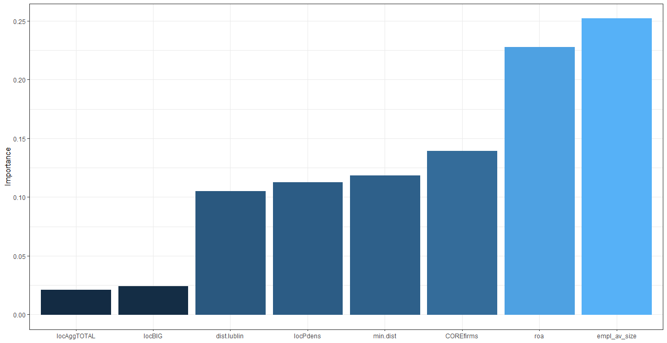 | 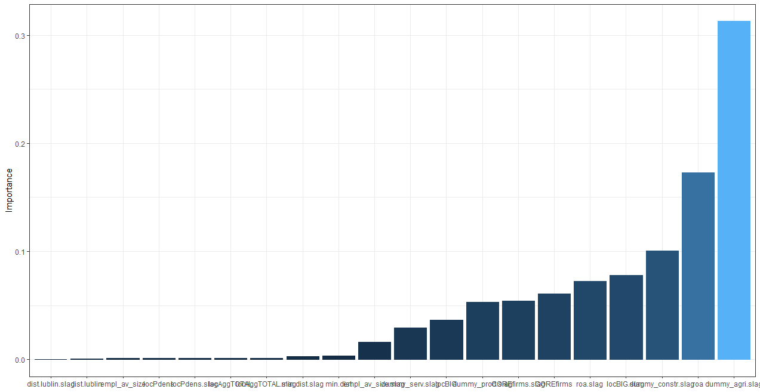
rel_imp x_names  4 0.02118440 locAggTOTAL  6 0.02433194 locBIG  7 0.10480237 dist.lublin  3 0.11243484 locPdens  8 0.11846524 min.dist  5 0.13912963 COREfirms  1 0.22756393 roa  2 0.25208766 empl_av_size | rel_imp x_names  19 0.0001351245 dist.lublin.slag  7 0.0008582003 dist.lublin  2 0.0009856369 empl_av_size  3 0.0011670541 locPdens  15 0.0011813541 locPdens.slag  4 0.0012846197 locAggTOTAL  16 0.0014611425 locAggTOTAL.slag  20 0.0029159521 min.dist.slag  8 0.0032207866 min.dist  14 0.0164203653 empl_av_size.slag  12 0.0291186129 dummy_serv.slag  6 0.0362935617 locBIG  10 0.0530904804 dummy_prod.slag  17 0.0544599702 COREfirms.slag  5 0.0606781508 COREfirms  13 0.0724594535 roa.slag  18 0.0777579223 locBIG.slag  11 0.1005636931 dummy_constr.slag  1 0.1730261777 roa  9 0.3129217412 dummy_agri.slag

Adding spatial lags did not improve accuracy. Possible reasons:
- spatial information already captured by density variables
- lags introduce noise
- classification problem already easy

# Extra codes

# ***Comparison of different specifications of NN models

# below we compare the different neural networks
# we change the number of hidden layers (here 1 or 2)
# we also change the number of neurons in each hidden layer (here 1 or 2)

# option likelihood=TRUE generates AIC and BIC in output
# option err.fct='ce' generates cross-entropy as error

eq<-SEC_agg ~ roa + empl + locPdens + locAggTOTAL + COREfirms + locBIG + dist.lublin + min.dist

# 1-Hidden Layer, Layer 1 with 1 neuron
set.seed(15)
Hab_NN1<-neuralnet(eq, data=train_data, linear.output=FALSE, err.fct='ce', likelihood=TRUE)
plot(Hab_NN1, rep="best")

# 2-Hidden Layers, Layer 1 with 2 neurons, Layer 2 with 1 neuron
set.seed(15)
Hab_NN2<-neuralnet(eq, data=train_data, linear.output=FALSE, err.fct='ce', likelihood=TRUE, hidden=c(2,1))
plot(Hab_NN2, rep="best")

# 2-Hidden Layers, Layer 1 with 2 neurons, Layer 2 with 2 neurons
set.seed(15)
Hab_NN3<-neuralnet(eq, data=train_data, linear.output=FALSE, err.fct='ce', likelihood=TRUE, hidden=c(2,2), stepmax=2e+05)
plot(Hab_NN3, rep="best")

# 2-Hidden Layers, Layer 1 with 1 neuron, Layer 2 with 2 neurons
set.seed(123)
Hab_NN4<-neuralnet(eq, data=train_data, linear.output=FALSE, err.fct='ce', likelihood=TRUE, hidden= c(1,2))
plot(Hab_NN4, rep="best")

Hab_NN1 | Hab_NN2
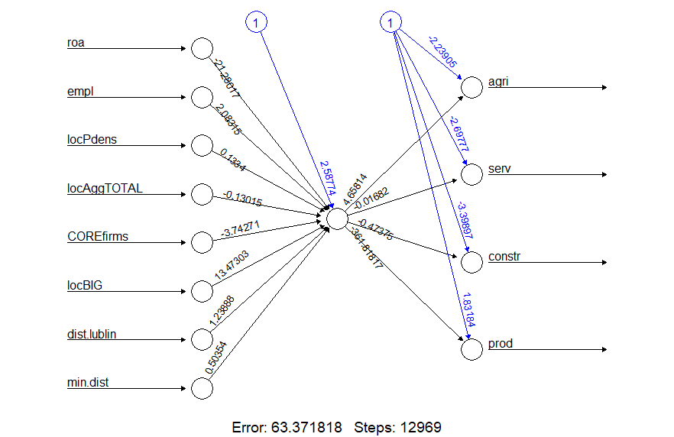 | 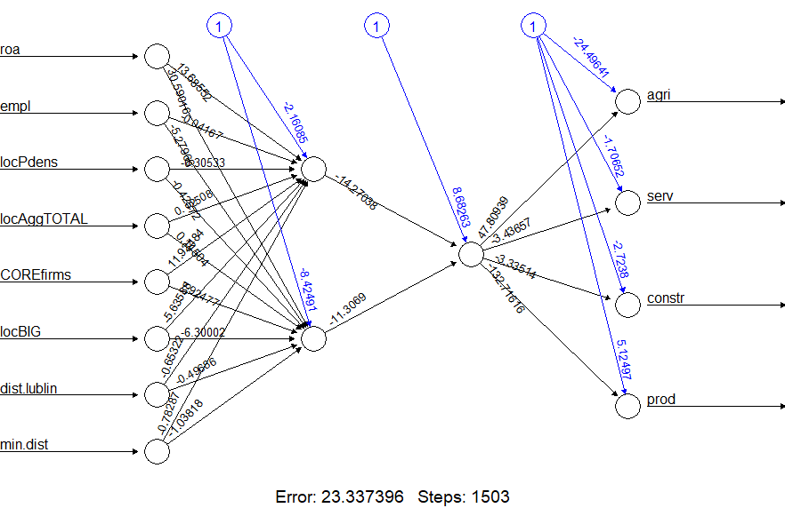
Hab_NN3 | Hab_NN4
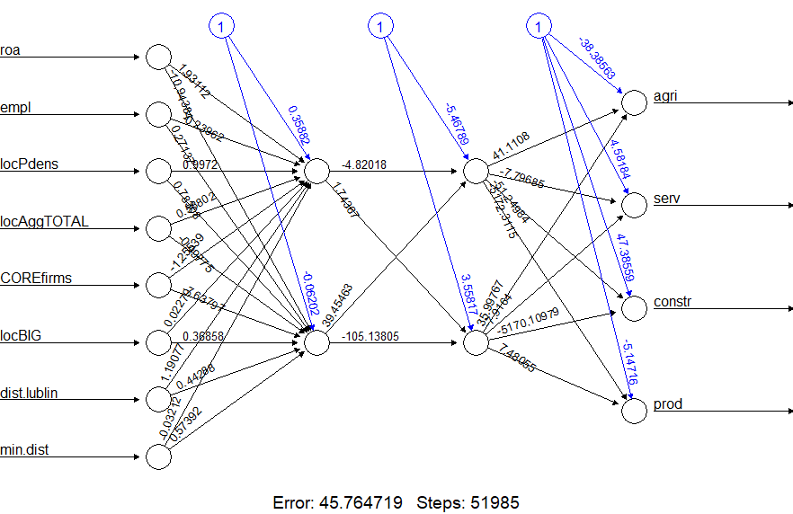 | 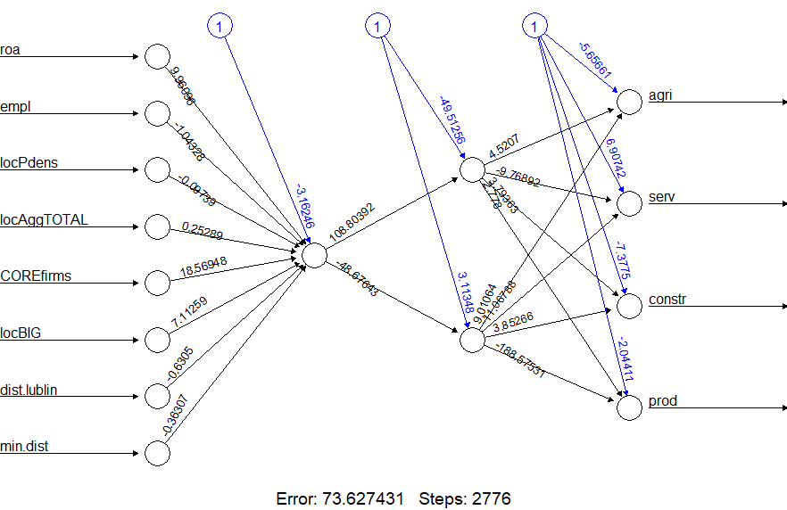

Class_NN_ICs <- tibble('Network' = rep(c("NN1", "NN2", "NN3", "NN4"), each = 3),
'Metric' = rep(c('AIC', 'BIC', 'ce Error * 100'), length.out = 12),
'Value' = c(Hab_NN1$result.matrix[4,1], Hab_NN1$result.matrix[5,1],
100*Hab_NN1$result.matrix[1,1], Hab_NN2$result.matrix[4,1],
Hab_NN2$result.matrix[5,1], 100*Hab_NN2$result.matrix[1,1],
Hab_NN3$result.matrix[4,1], Hab_NN3$result.matrix[5,1],
100*Hab_NN3$result.matrix[1,1], Hab_NN4$result.matrix[4,1],
Hab_NN4$result.matrix[5,1], 100*Hab_NN4$result.matrix[1,1]))
Class_NN_ICs
# A tibble: 12 × 3
Network Metric Value
<chr> <chr> <dbl>
1 NN1 AIC 297.
2 NN1 BIC 338.
3 NN1 ce Error * 100 13158.
4 NN2 AIC 129.
5 NN2 BIC 198.
6 NN2 ce Error * 100 3567.
7 NN3 AIC 164.
8 NN3 BIC 249.
9 NN3 ce Error * 100 4576.
10 NN4 AIC 197.
11 NN4 BIC 257.
12 NN4 ce Error * 100 7363.

Class_NN_ICs %>%
ggplot(aes(Network, Value, fill=Metric)) +
geom_col(position = 'dodge') +
ggtitle("AIC, BIC, and Cross-Entropy Error of the Classification ANNs", "Note: ce Error displayed is 100 times its true value")

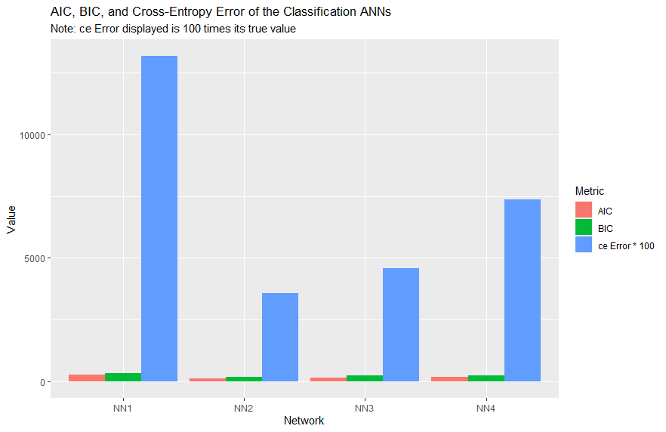

# check what we have plotted

Hab_NN1$result.matrix # see the first five lines
[,1]
error 131.583728123
reached.threshold 0.006212298
steps 30.000000000
Intercept.to.1layhid1 0.340822873
roa.to.1layhid1 1.913120700
empl.to.1layhid1 -0.257618568
locPdens.to.1layhid1 0.979198170
locAggTOTAL.to.1layhid1 0.570016284
COREfirms.to.1layhid1 -1.555385820
locBIG.to.1layhid1 0.022788205
dist.lublin.to.1layhid1 1.172773212
min.dist.to.1layhid1 -0.050122440
Intercept.to.agri -0.762229405
1layhid1.to.agri 1.167782625
Intercept.to.serv -1.619855139
1layhid1.to.serv -1.089320705
Intercept.to.constr -3.182784991
1layhid1.to.constr -0.480712315
Intercept.to.prod -0.385412769
1layhid1.to.prod -0.402683173

Hab_NN1$result.matrix | Hab_NN2$result.matrix
error 131.583728123  reached.threshold 0.006212298  steps 30.000000000  aic 297.167456245  bic 337.661909035 | error 3.567278e+01  reached.threshold 9.262939e-03  steps 3.708300e+04  aic 1.293456e+02  bic 1.984243e+02
Hab_NN3$result.matrix | Hab_NN4$result.matrix
error 4.576472e+01  reached.threshold 9.550444e-03  steps 5.198500e+04  aic 1.635294e+02  bic 2.492824e+02 | error 7.362743e+01  reached.threshold 7.633699e-03  steps 2.776000e+03  aic 1.972549e+02  bic 2.568055e+02

# *** calculating spatial lag for subsample of points
# spatial lag is the average of values in the neighbourhood
# instead of typical spatial weights matrix algorithm we can operationalize it
# with indicating who is a neighbour and calculating a mean on subsample

library(dbscan) # for finding neighbours around
# finding nearest neigbours – fixed knn
crds.all<-firms[,77:78] # matrix of coordinates for all points
aaa<-kNN(crds.all, 10) # k=10 nearest neighbours
aaa$id[1,] # list of neighbours for obs no 1

# alternative - finding nearest neigbours – fixed radius
#aaa<-frNN(crds.all, 0.05) # radius of ca.5 km
#aaa$id[[1]] # see that reference is different than before

# checking what to select
firms[30694-1,] # IDD-1
train_data$roa.listw<-0

for(i in 1:dim(train_data)[1]){ # for train data
IDD<-train_data$IDD[i]
neigh<-aaa$id[IDD-1,]
temp<-mean(firms$roa[neigh])
train_data$roa.listw[i]<-temp}

for(i in 1:dim(test_data)[1]){ # for test data
IDD<-test_data$IDD[i]
neigh<-aaa$id[IDD-1,]
temp<-mean(firms$roa[neigh])
test_data$roa.listw[i]<-temp}

